

**Project Title: Mobile Usage Analysis: Devices, Data, and User Insights**

**Name- Divyanshi Jain**

**Registration Number: CU24140031**

**Course and Semester: MBA, Sem-1**

**Submission Date: 22nd November, 2024**

**Faculty: Dr Sourabh Poswal**

**Table of Contents**

1. **Title Page**
2. **Executive Summary**
3. **Introduction**
4. **Why Power BI**
5. **Stakeholders**
6. **Data Overview**
7. **Power BI Process**
8. **Insights and Analysis**
9. **Conclusion**

**Executive Summary**

**Project Objectives**

This report presents a detailed analysis of mobile app usage and data consumption trends across various demographics, focusing on age, gender, and device preferences. The objective is to empower app developers, marketers, device manufacturers, and service providers to make data-driven decisions to address diverse user needs effectively. Key goals include:

1. **Enhance App Features**: Design apps with features tailored to specific user segments.
2. **Optimize Marketing Campaigns**: Develop marketing strategies informed by demographic-specific engagement and consumption patterns.
3. **Improve Device Performance**: Identify optimization opportunities in battery life and device performance.
4. **Design Service Offerings**: Create customized mobile data plans and targeted promotions.

**Key Insights**

The analysis uncovered key insights about mobile app usage, data consumption, and device performance, segmented by demographics. These insights help businesses understand user behaviour and guide decisions in product development, marketing, and service design.

**Introduction**

**Context**

The mobile app market has become a vital part of daily life, with diverse user groups exhibiting varying behaviours and preferences. A deeper understanding of these patterns enables businesses to create better products and more effective marketing strategies.

**Key Behavioural Trends:**

1. Younger users (18–25) consume more data, install more apps, and spend more time on their devices.
2. Older users (56+) prefer practical and simplified apps, using fewer features and consuming less data.

This report provides actionable insights into these behaviours, offering businesses a competitive edge in tailoring their strategies.

**Objective**

The report addresses critical questions:

1. Which age groups exhibit the highest data usage and app installations?
2. How do gender and age affect app engagement and device performance?
3. What are the preferred devices and operating systems among different demographics?

By answering these questions, this report provides a roadmap for enhancing customer satisfaction and business performance.

**Why Power BI?**

Power BI is a leading business intelligence and data visualization tool that empowers users to make data-driven decisions through interactive and visually appealing reports. Here’s an in-depth explanation of why Power BI stands out as the ideal tool for analysing mobile app usage and data consumption patterns:

**1. User-Friendly Interface**

Power BI is designed to be intuitive, even for users without extensive technical expertise. Its drag-and-drop functionality, pre-built templates, and user-friendly interface enable anyone to build powerful dashboards and reports quickly.

* Example: App developers can easily visualize user engagement metrics, such as daily active users or app retention rates, without needing advanced coding skills.

**2. Seamless Integration with Multiple Data Sources**

Power BI supports a wide range of data sources, including Excel, SQL databases, APIs, and cloud services like Google Analytics and Azure. This flexibility allows analysts to combine data from various platforms into a single cohesive report.

* Example: A marketing team analysing mobile app performance can combine app usage statistics, social media metrics, and customer feedback data to identify trends and pain points.

**3. Real-Time Data Analysis**

Power BI supports real-time data analysis, enabling businesses to track changes and trends as they happen. This is crucial for industries like mobile app development, where user behaviour can shift rapidly due to new features or updates.

* Example: A mobile game developer can monitor in-app purchases and engagement in real time after a major update, allowing them to address issues or roll out fixes immediately.

**4. Advanced Data Visualization**

Power BI offers a rich array of visual elements, including charts, graphs, heat maps, and slicers, to help users present data in an easily digestible format. Interactive dashboards allow stakeholders to explore data from different perspectives with just a few clicks.

* Example: An app usage analysis report can display demographics-based heat maps showing which regions have the highest number of active users, enabling targeted marketing efforts.

**5. Scalability for Small and Large Organizations**

Power BI is scalable, catering to the needs of both small businesses and large enterprises. Its cloud-based service, Power BI Pro, allows organizations to share and collaborate on dashboards securely, making it a collaborative tool for teams.

* Example: A start up App Company can use Power BI to track user growth metrics, while a large multinational can analyse global app usage trends across different markets.

**6. Customizable and Extendable**

Power BI allows customization through its DAX (Data Analysis Expressions) language, enabling analysts to create complex calculations and tailored metrics. Additionally, its integration with R and Python allows users to incorporate advanced statistical modelling and machine learning capabilities.

* Example: An analyst can use DAX formulas to calculate metrics like churn rates or average revenue per user (ARPU), providing deeper insights into app performance.

**7. Cost-Effective Solution**

Compared to other business intelligence tools, Power BI is relatively affordable, especially for small and medium-sized enterprises. Its free version, Power BI Desktop, is a great starting point, while the Pro version offers more advanced features at a competitive price.

* Example: A new app development company with budget constraints can leverage Power BI Desktop to start analysing their user data without incurring additional costs.

**Stakeholders**

Stakeholders are the individuals or groups that benefit from the insights provided in this analysis of mobile app usage and data consumption trends. These stakeholders play vital roles in the app ecosystem, and their decisions are shaped by the data-driven recommendations derived from Power BI. Here’s how the insights cater to their needs:

**1. App Developers**

* Relevance: Developers need to understand how users interact with their apps to improve user experience and enhance app features.
* Insights: For example, the finding that younger users (18–25) spend significantly more time on apps (290 minutes/day) highlights the importance of creating engaging, feature-rich apps for this demographic.
* Actionable Use: Developers can prioritize updates or enhancements that appeal to this audience, such as gamified features or social integrations. Additionally, insights into battery consumption can guide developers to optimize their apps to minimize resource usage, improving user satisfaction.

**2. Marketers**

* Relevance: Marketing teams can use demographic-specific insights to craft targeted campaigns. Knowing which age group or gender prefers certain devices or uses specific apps heavily is critical for successful promotions.
* Insights: Insights like Android’s dominance (80% market share) and iOS’s preference among high-income users allow marketers to align campaigns with their target audience’s preferences.
* Actionable Use: Campaigns for budget-friendly apps or services could target Android users, while premium services could focus on iOS users to maximize reach and impact.

**3. Device Manufacturers**

* Relevance: Manufacturers need performance data, such as battery drain or app installation patterns, to design better devices.
* Insights: Data showing that the iPhone 12 experiences the highest battery drain while the Google Pixel 5 is the most efficient indicates where manufacturers can improve.
* Actionable Use: Companies like Apple can use these insights to innovate in battery technology for future models, while competitors can market their devices’ superior efficiency to attract customers.

**4. Service Providers**

* Relevance: Service providers benefit from understanding data usage trends to create competitive mobile data plans.
* Insights: Younger users (18–25) consuming the most data (976–985 MB/day) suggests a need for high-data plans for this group, while older users (56+) with lower data usage could benefit from affordable, limited-data options.
* Actionable Use: Providers can segment their offerings, promoting high-data plans with fast speeds to younger users and budget-friendly plans to older users.

**Data Overview**

The data overview describes the sources, preparation, and segmentation of the data used in the analysis. Understanding the dataset’s structure is crucial for generating accurate and meaningful insights.

**Data Sources**

The analysis draws from a comprehensive dataset from a CSV file that includes metrics on app usage, user demographics, and device performance. Key sources include:

User Demographics: Age, gender, and operating system preferences.

App Metrics: Screen-on time, app installations, and data consumption per day.

Device Metrics: Battery consumption and device preferences.

**Data Description**

The dataset includes the following key columns:

* **User ID**
* **Device Model**
* **Operating System**
* **App Usage Time (min/day)**
* **Screen On Time (hours/day)**
* **Battery Drain (mAh/day)**
* **Number of Apps Installed**
* **Data Usage (MB/day)**
* **Age**
* **Gender**
* **User Behaviour Class**

**Data Preparation**

Before visualization, the data undergoes cleaning and transformation to ensure accuracy and consistency:

Cleaning: Duplicates and missing values are addressed to create a reliable dataset.

Segmentation: Users are segmented by age groups (e.g., 18–25, 56+) and gender to allow targeted analysis.

**Power BI Process**

The Power BI process involves the steps taken to transform raw data into interactive, insightful dashboards. This process ensures that data is not only clean and organized but also visually engaging and easy to understand for stakeholders.

**1. Dashboard Design**

Power BI dashboards are tailored to address specific aspects of the analysis:

* General Overview Dashboard: Highlights user demographics, such as gender distribution and operating system preferences.
  + Example: A pie chart shows Android’s 80% market share compared to iOS’s 20%.
* Usage Insights Dashboard: Focuses on metrics like data consumption, app installations, and screen-on time by age group.
  + Example: A bar chart comparing app installations by age group reveals the 18–25 group’s higher engagement levels.
* Device Performance Dashboard: Showcases battery and data usage patterns across devices.
  + Example: A line graph illustrates how the Xiaomi Mi 11 leads in data consumption while the iPhone 12 faces the highest battery drain.

**2. Visualization Techniques**

Power BI’s diverse visualization tools make data interpretation easier:

* Pie Charts: Useful for showing proportions, such as the gender distribution among app users (48% male, 52% female).
* Bar Charts: Ideal for comparing metrics like app installations or screen-on time across age groups.
* Line Graphs: Help identify trends, such as fluctuations in data usage over time or variations in battery consumption by device.

**3. Interactivity and Customization**

Power BI dashboards are interactive, allowing stakeholders to filter data dynamically:

* Example: A marketing manager can filter app usage data by age group to focus solely on younger users, gaining insights into their preferences.

**4. Real-Time Data Refresh**

With Power BI’s real-time capabilities, dashboards reflect the latest data; ensuring decisions are based on current trends:

* Example: After a new app feature is launched, the usage insights dashboard updates to show whether engagement has increased.

**5. Collaboration and Accessibility**

Power BI enables stakeholders to share and collaborate on dashboards seamlessly. Its cloud-based platform ensures accessibility from anywhere:

* Example: A developer and marketer can discuss user engagement metrics during a video conference, using the same live dashboard for reference

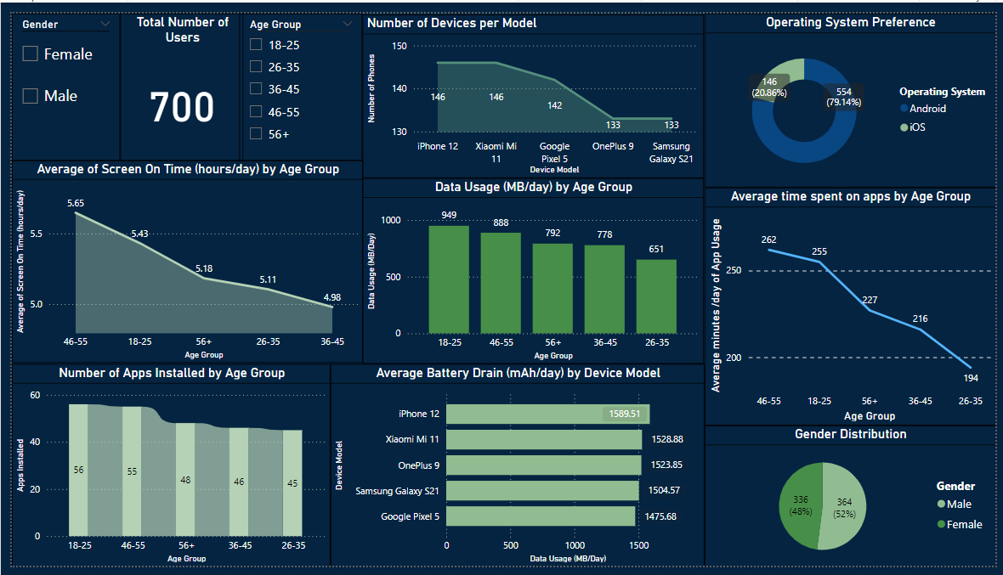

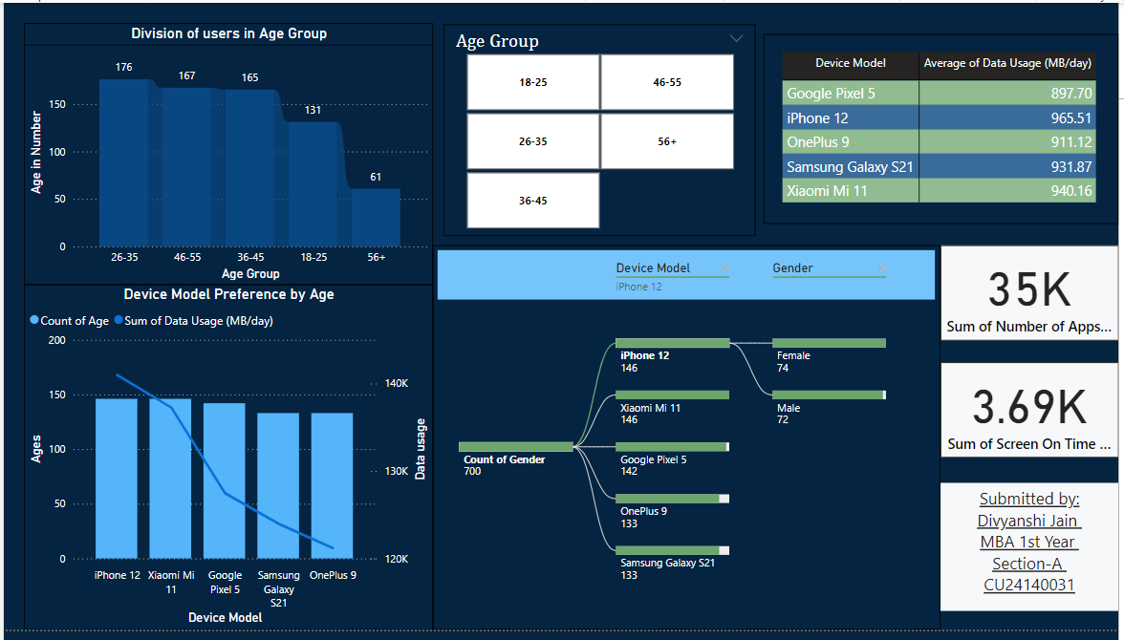

**Insights and Analysis**

**General Insights and Visualisations**

1. **Operating System Preference**:
   * **Outcome**: Android leads with 80% of the market share, while iOS holds 20%.
   * 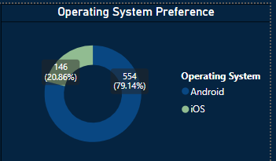
   * **Significance**: Businesses should prioritize Android app development while catering premium services to iOS users.
2. **Gender Distribution**:
   * **Outcome**: The user base is nearly balanced, with males (52%) slightly outnumbering females (48%).
   * 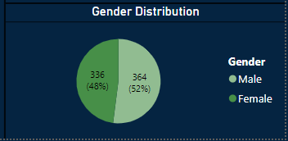
   * **Significance**: Marketing efforts should be gender-inclusive, addressing subtle preferences in app and device use.
3. **Engagement Rates**:
   * **Outcome**: Younger users (18–25) and users aged 46–55 exhibit the highest engagement rates, spending the most time on apps.
   * 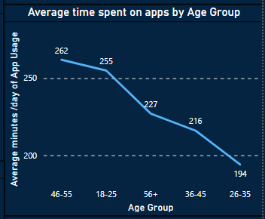
   * **Significance**: Businesses can focus on creating feature-rich apps for these groups to maximize retention.
4. **Data Usage by Age**:
   * **Outcome**: The 18–25 group consumes the most data (median 949 MB/day), while the 56+ group consumes the least.
   * 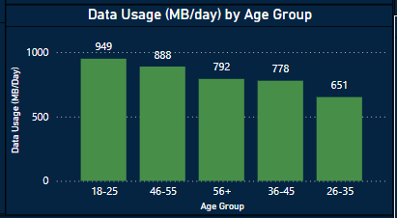
   * **Significance**: Data-heavy services should target younger demographics.
5. **App Installations by Age**:
   * **Outcome**: Younger users install more apps (median 56 apps), while older users install fewer (median 43 apps).
   * 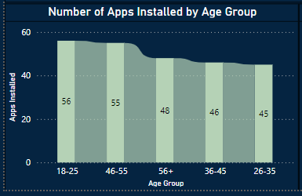
   * **Significance**: App developers should focus on user-friendly apps for older demographics.
6. **Time Spent on Apps**:
   * **Outcome**: Users aged 46–55 spend the most time on apps, averaging 5.65 hours/day.
   * 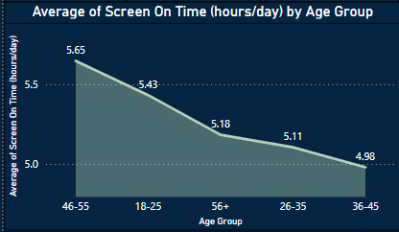
   * **Significance**: Designing engaging app experiences can boost user retention in this age group.
7. **Battery Drain by Device**:
   * **Outcome**: The iPhone 12 has the highest battery consumption (average 1,576 mAh/day), while the Google Pixel 5 is the most efficient.
   * 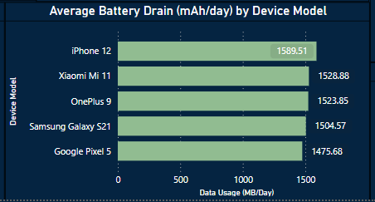
   * **Significance**: Developers should prioritize energy efficiency for high-drain devices.
8. **Data Consumption by Device**:
   * **Outcome**: iPhone 12 and Xiaomi Mi 11 users consume the most data, followed by Samsung Galaxy S21 users.
   * 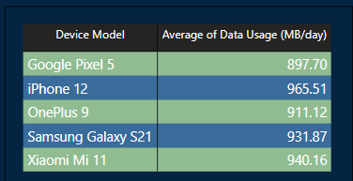
   * **Significance**: These devices are ideal for promoting data-heavy apps and services.
9. **Device Preferences by Age**:

* **Outcome**: Younger users prefer high-performance devices, while older users opt for simpler models.
* 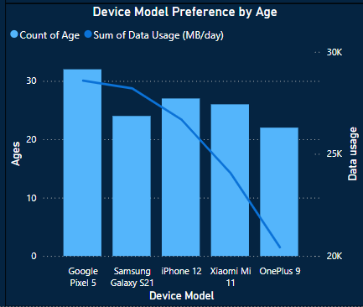
* **Significance**: Manufacturers should design devices with features tailored to different age groups.

1. **Device Preference by Gender**

* **Outcome**: Females users prefer iPhone 12, followed closely by Xiaomi Mi 11. While, Samsung Galaxy S21 and OnePlus 9 is popular among males.
* 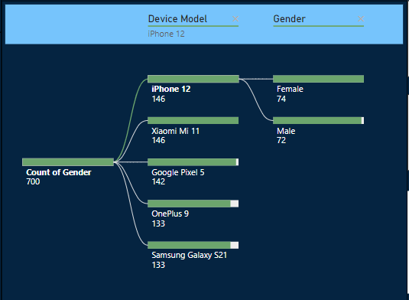
* **Significance**: App developers should keep these preferences in mind to sell their apps catered to specific genders.

**Conclusion**

The insights in this analysis provide a comprehensive understanding of mobile app usage and data consumption across demographics. These findings enable businesses to optimize app design, marketing strategies, and service offerings.

**Recommendations**

1. **For Younger Users (18–25)**:
   * Focus on feature-rich, data-heavy apps.
   * Promote high-data plans and high-performance devices.
2. **For Older Users (56+)**:
   * Develop practical, user-friendly apps.
   * Offer battery-efficient and durable devices.
3. **For Device Manufacturers**:
   * Improve battery efficiency and durability.
   * Promote targeted features for different age groups.
4. **For Service Providers**:
   * Design tiered data plans catering to varied consumption levels.